Project Code

**MySQL:**

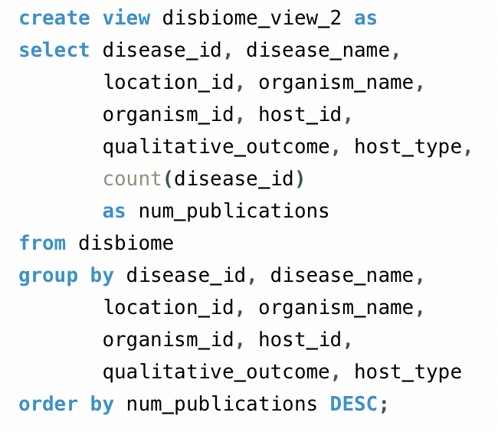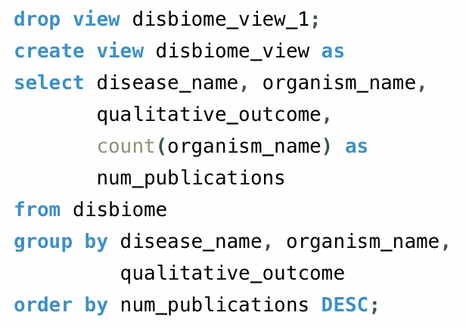

**Which diseases (or which bacteria) are the most heavily studied?**

select organism_name, count(organism_id) as num_publications, sample_name

from disbiome

group by organism_name

order by num_publications DESC;

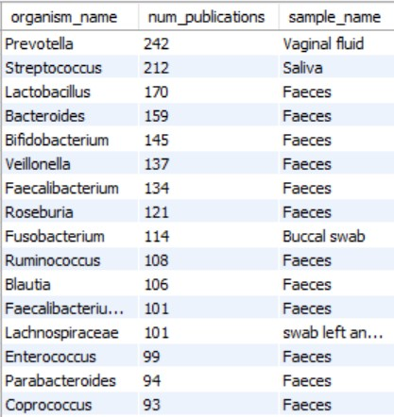

select disease_name, count(disease_id) as num_publications, sample_name

from disbiome

group by disease_name

order by num_publications DESC

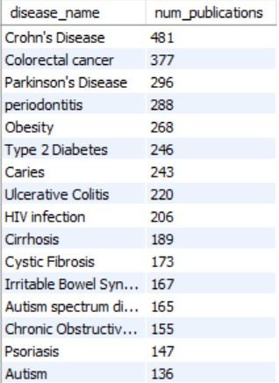

**Which bacterium is linked to the greatest number of diseases?**

select distinct organism_name, count(disease_id) as num_diseases, sample_name

from disbiome

group by organism_id, disease_id

order by count(organism_id) desc;

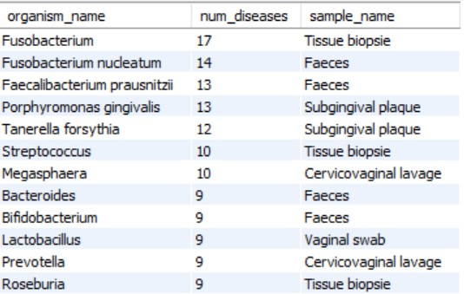

**Neo4j:**

call apoc.load.jdbc("jdbc:mysql://localhost:3306/disbiome?serverTimezone=EST5EDT&user=ds4300user&password=ds4300password", "disbiome_view_1") yield row

merge (o:Organism {organism:row.organism_name})

merge (d:Disease {disease:row.disease_name})

merge (h:Host {host_id:row.host_id, host_type:row.host_type, control_name:row.control_name})

merge (o)-[:Assoc {publications:row.num_publications, outcome:row.qualitative_outcome}]->(d)

merge (o)-[:lives_in]->(h)

return o,d,h

call apoc.load.jdbc("jdbc:mysql://localhost:3306/disbiome?serverTimezone=EST5EDT&user=disbiome&password=disbiome", "disbiome_gad_view") yield row

merge (o:Organism {organism_id: row.organism_id, organism:row.organism_name,location:row.location_id,sample_name:row.sample_name, organism_ncbi_id:row.organism_ncbi_id})

merge (d:Disease {disease:row.disease_name, disease_id:row.disease_id, meddra_level: row.meddra_level, meddra_id:row.meddra_id,class:row.disease_class})

merge (h:Host {host_id:row.host_id, host_type:row.host_type, control_name:row.control_name})

merge (o)-[:Assoc {publications:row.num_publications, outcome:row.qualitative_outcome}]->(d)

merge (o)-[:lives_in]->(h)

return o,d,h

Queries:

**Which bacteria are linked to Covid-19?**

match (o:Organism)-[a:Assoc]->(d:Disease {disease:"Covid-19"})

return o, a, d

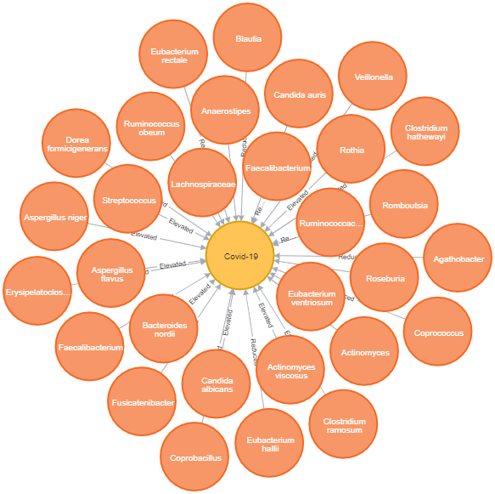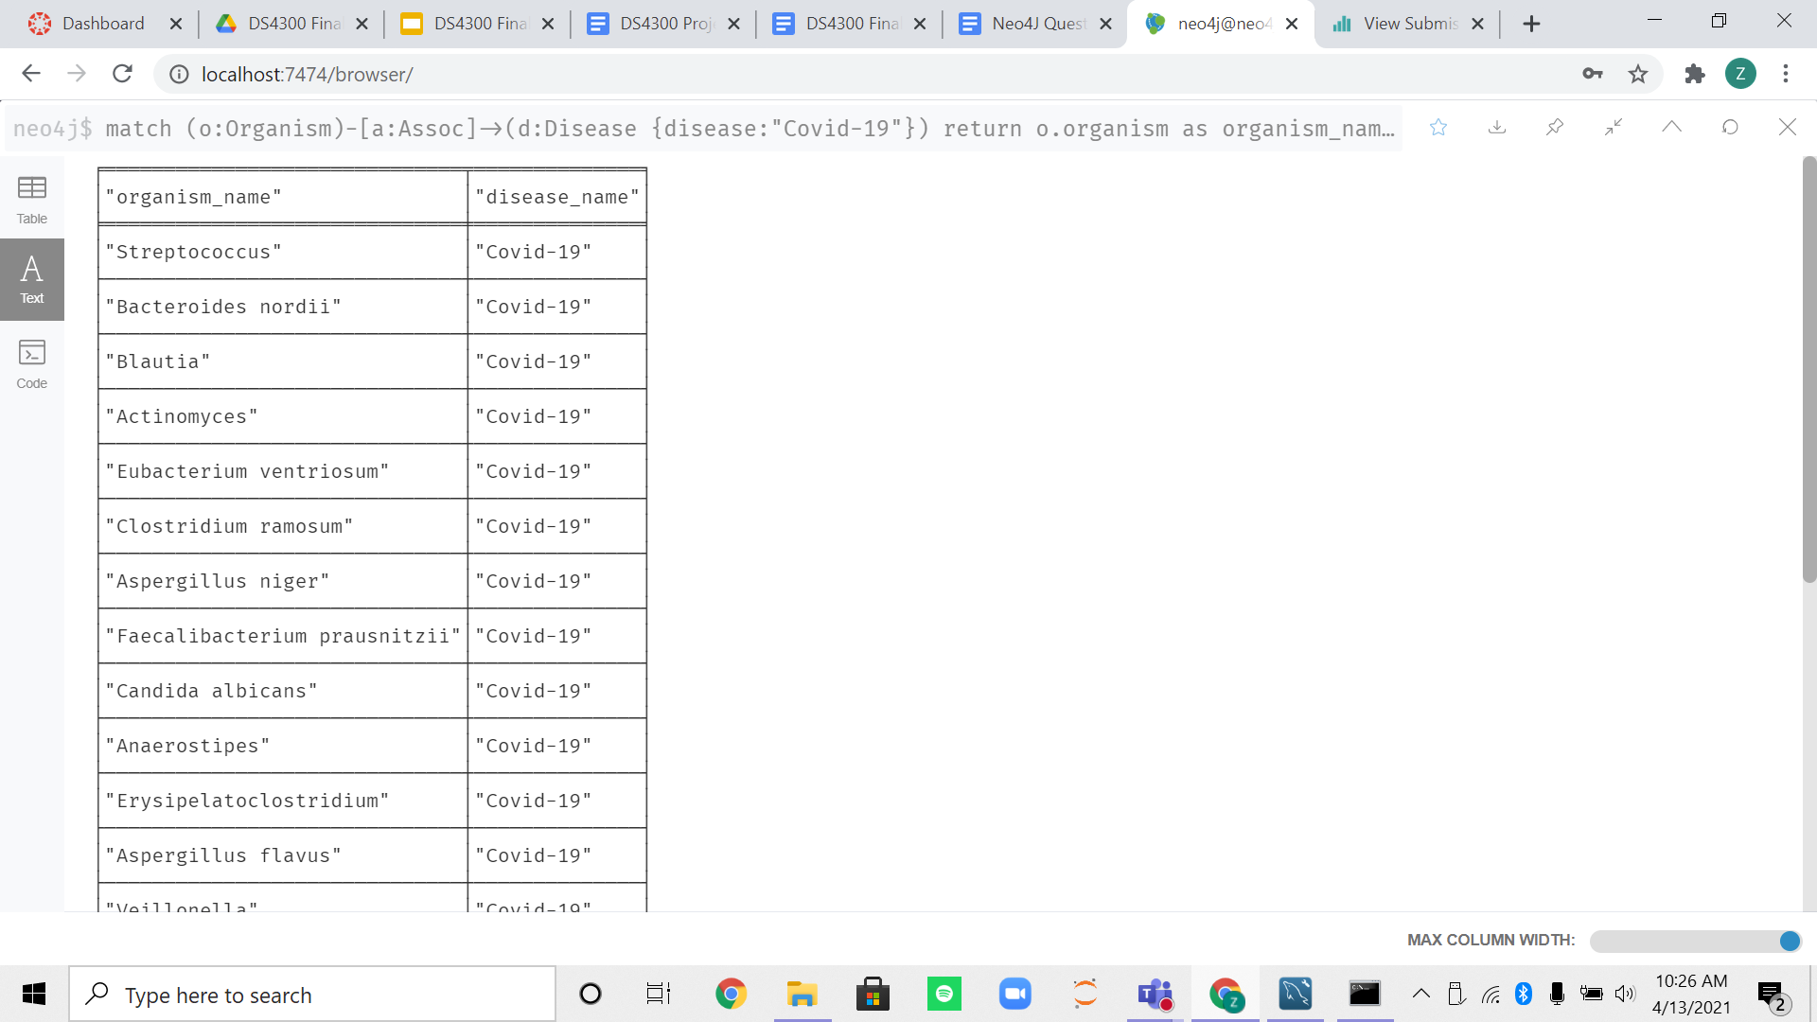

**What diseases are associated with bacteria linked to Covid-19?**

call {

match (o:Organism)-[a:Assoc]->(d:Disease {disease:"Covid-19"})

return collect(o.organism) as bacteria

}

match (o:Organism)-[a:Assoc]->(d:Disease)

where o.organism in bacteria

return o, a, d

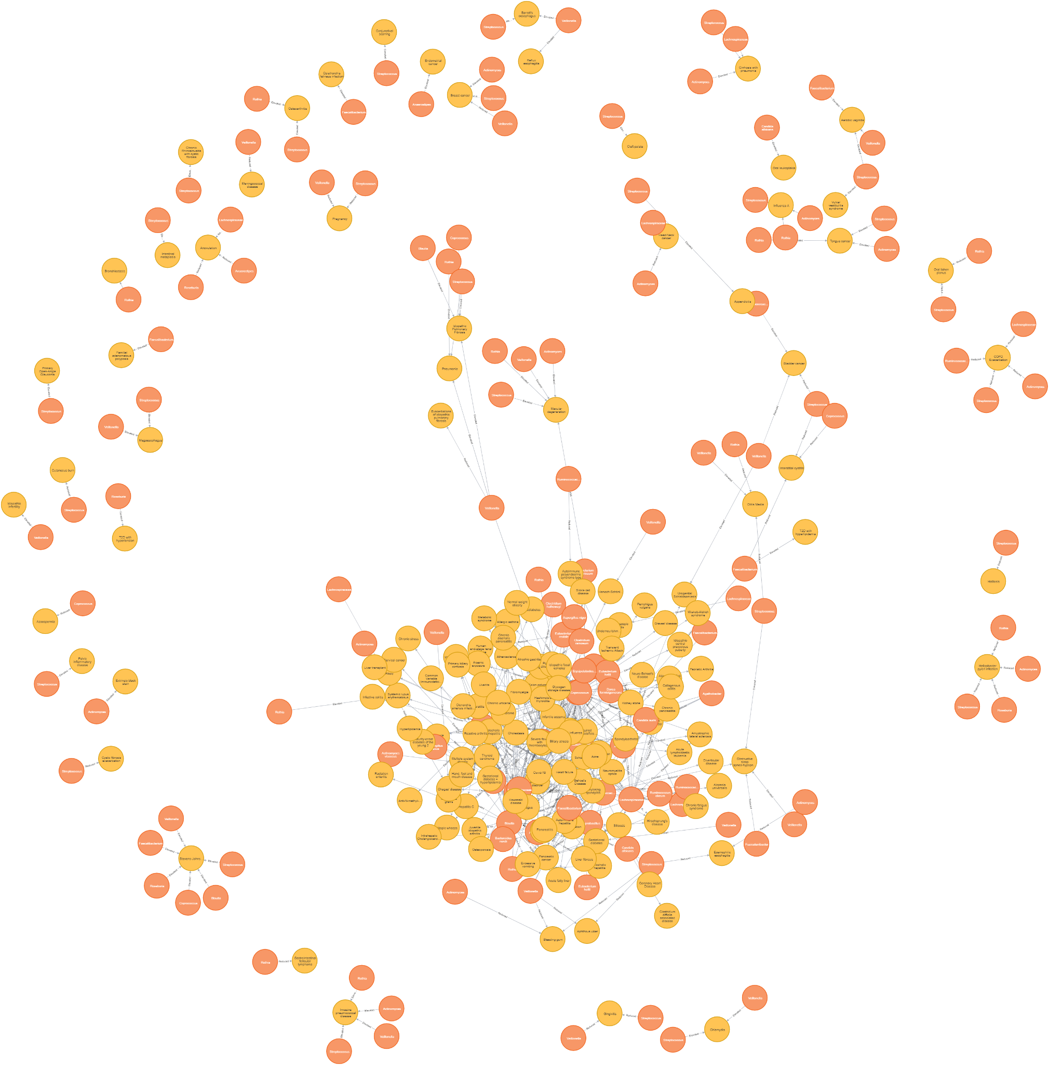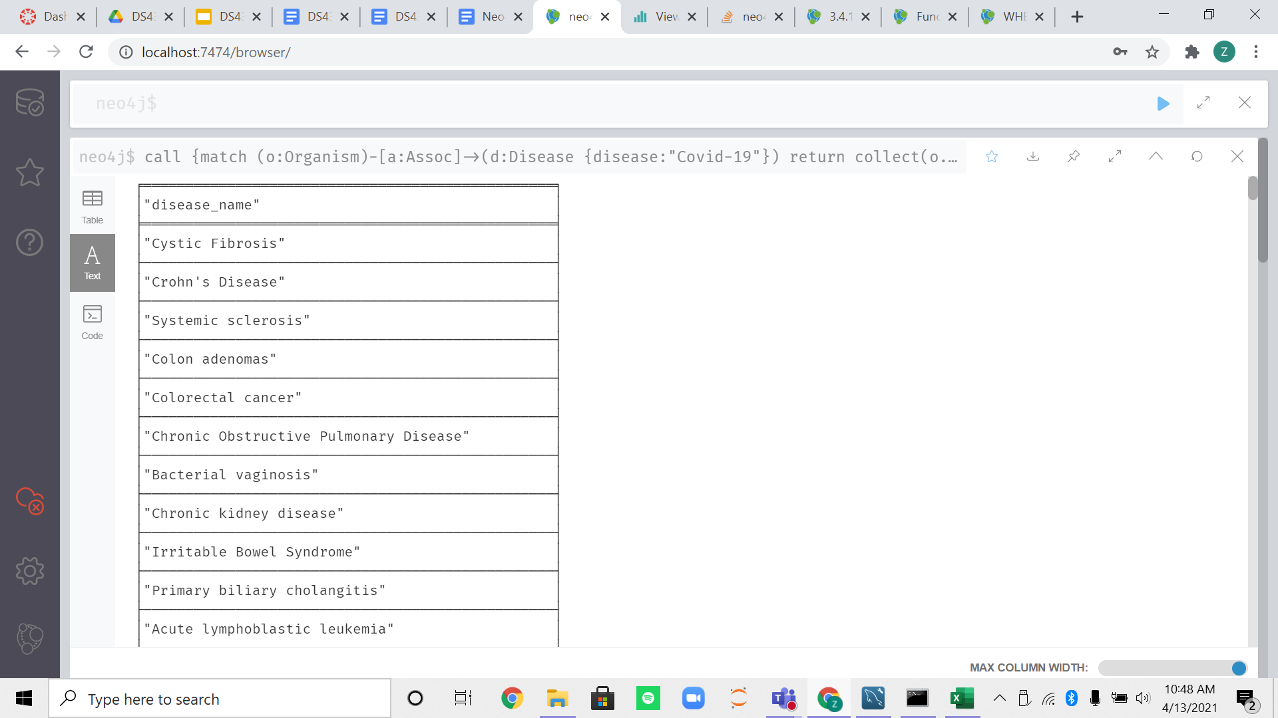

**Which bacteria are linked to diabetes (any type)?**

match (o:Organism)-[a:Assoc]->(d:Disease)

where d.disease =~ ".*diabetes.*" or d.disease =~".*Diabetes.*"

return o, a, d

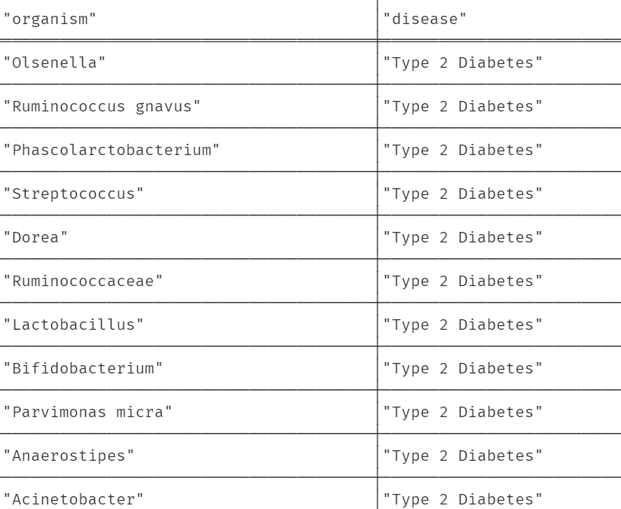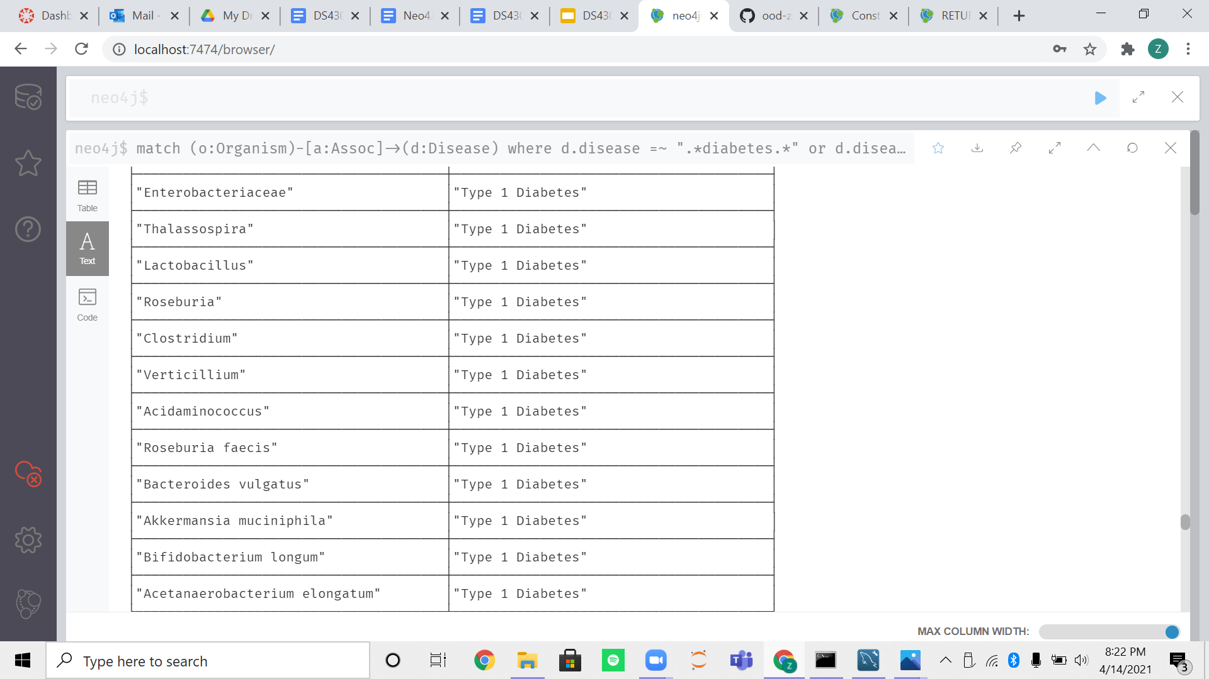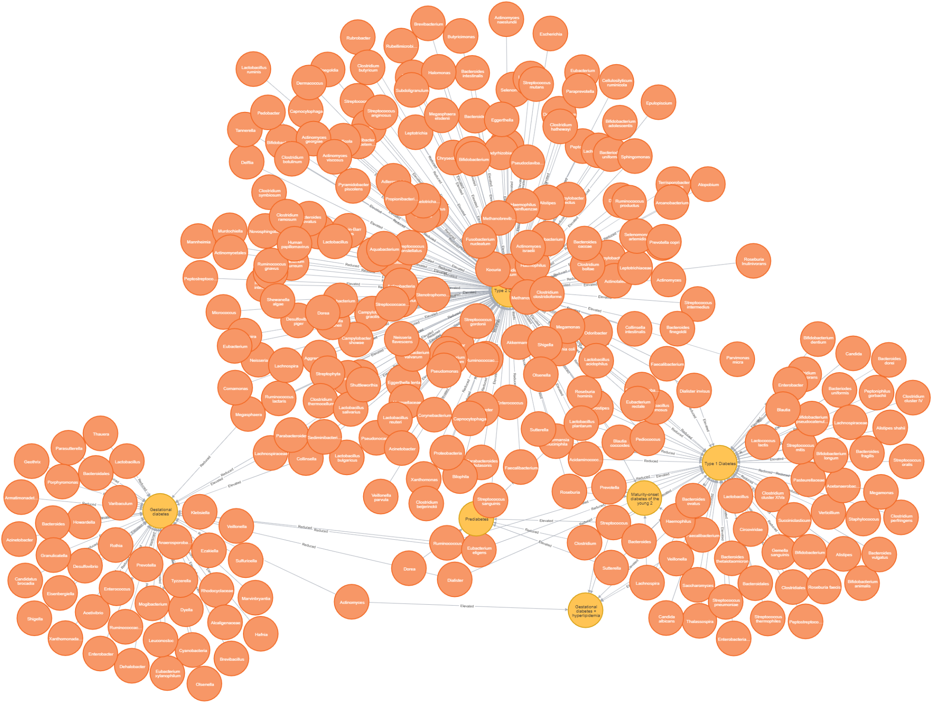

**Bacteria in common among the diabetes types**

**\*nothing for gestational diabetes or prediabetes**

match (o:Organism)-[a]->(d:Disease{disease:"Type 2 Diabetes"})

match(o)-[a2]->(d2:Disease{disease:"Type 1 Diabetes"})

match(o)-[a3:Assoc]->(d3:Disease{disease:"Maturity-onset diabetes of the young 2"})

match(o)-[a4:Assoc]->(d4:Disease{disease:"Gestational diabetes + hyperlipidemia"})

return o, a, d, d2, a2, d3, a3, d4, a4

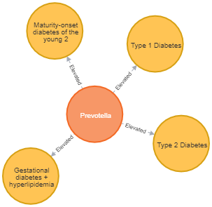

**Which diseases are most linked to specific gut bacteria?**

match (o:Organism)-[a:Assoc]->(d:Disease)

where a.publications > 1

return o.organism as organism, sum(a.publications) as npubs, d.disease as disease

order by npubs desc

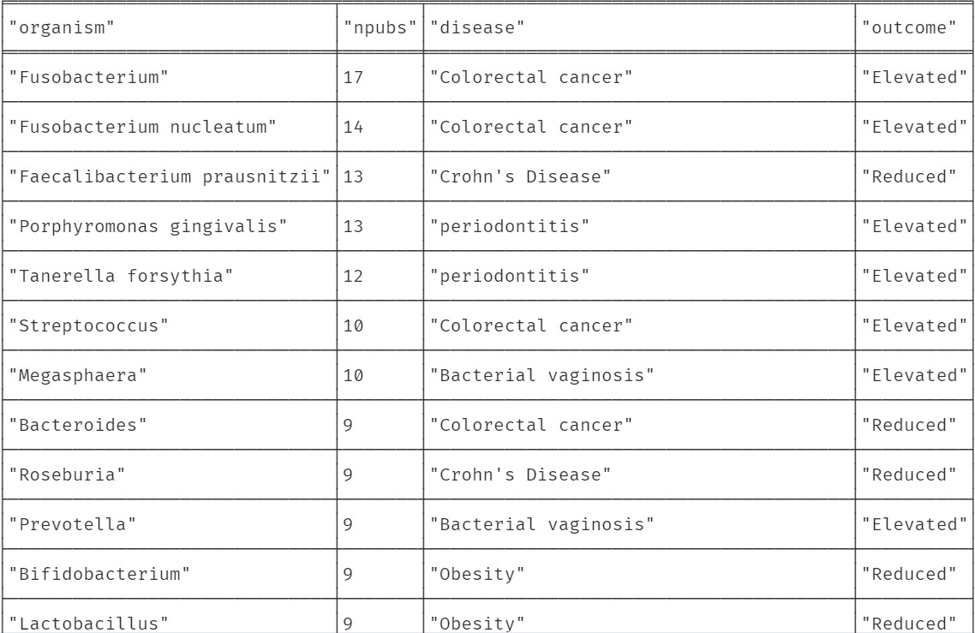

**Which bacteria do neurodegenerative diseases have a common link to?**

**Alzheimer’s Disease, Parkinson’s Disease, Amyotrophic lateral sclerosis, Multiple Sclerosis**

match (o:Organism)-[a:Assoc]->(d:Disease{disease:"Alzheimer's Disease"})

match(o)-[a2:Assoc]->(d2:Disease{disease:"Parkinson's Disease"})

match(o)-[a3:Assoc]->(d3:Disease{disease:"Amyotrophic lateral sclerosis"})

match(o)-[a4:Assoc]->(d4:Disease{disease:"Multiple Sclerosis"})

return o, a, d, d2, a2, a3, d3, a4, d4

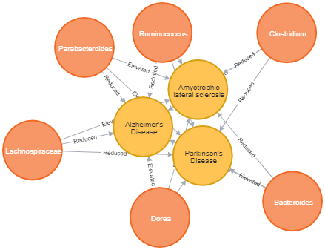

**Which diseases are connected to the bacteria linked to the 3 neurodegenerative diseases listed above?**

call {

match (o:Organism)-[a:Assoc]->(d:Disease{disease:"Alzheimer's Disease"})

match(o)-[a2:Assoc]->(d2:Disease{disease:"Parkinson's Disease"})

match(o)-[a3:Assoc]->(d3:Disease{disease:"Amyotrophic lateral sclerosis"})

match(o)-[a4:Assoc]->(d4:Disease{disease:"Multiple Sclerosis"})

return collect(o.organism) as bacteria

}

match (o:Organism)-[a:Assoc]->(d:Disease)

where o.organism in bacteria

return o, a, d

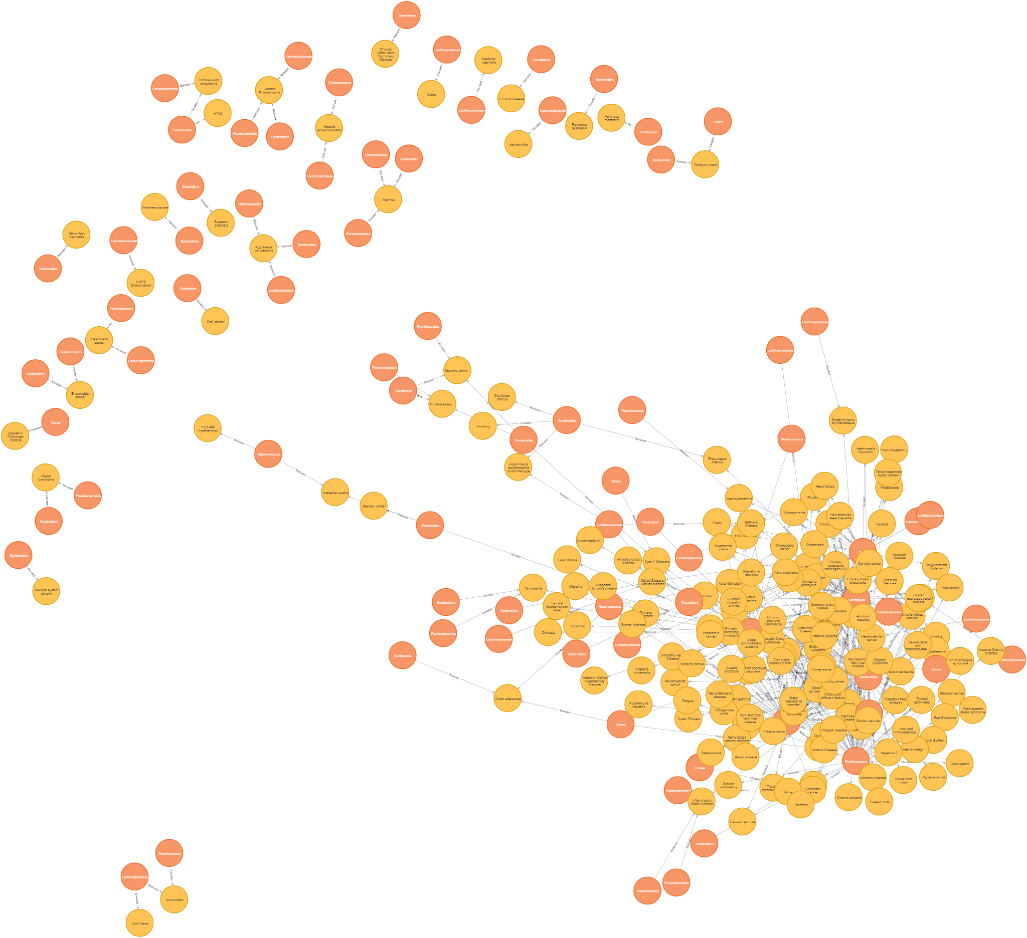

**What diseases are associated with bacteria linked to cancer?**

call {

match (o:Organism)-[a:Assoc]->(d:Disease)

where d.disease =~ ".*cancer.*" or d.disease =~".Cancer.*"

return collect(o.organism) as bacteria

}

match (o:Organism)-[a:Assoc]->(d:Disease)

where o.organism in bacteria

return o, a, d

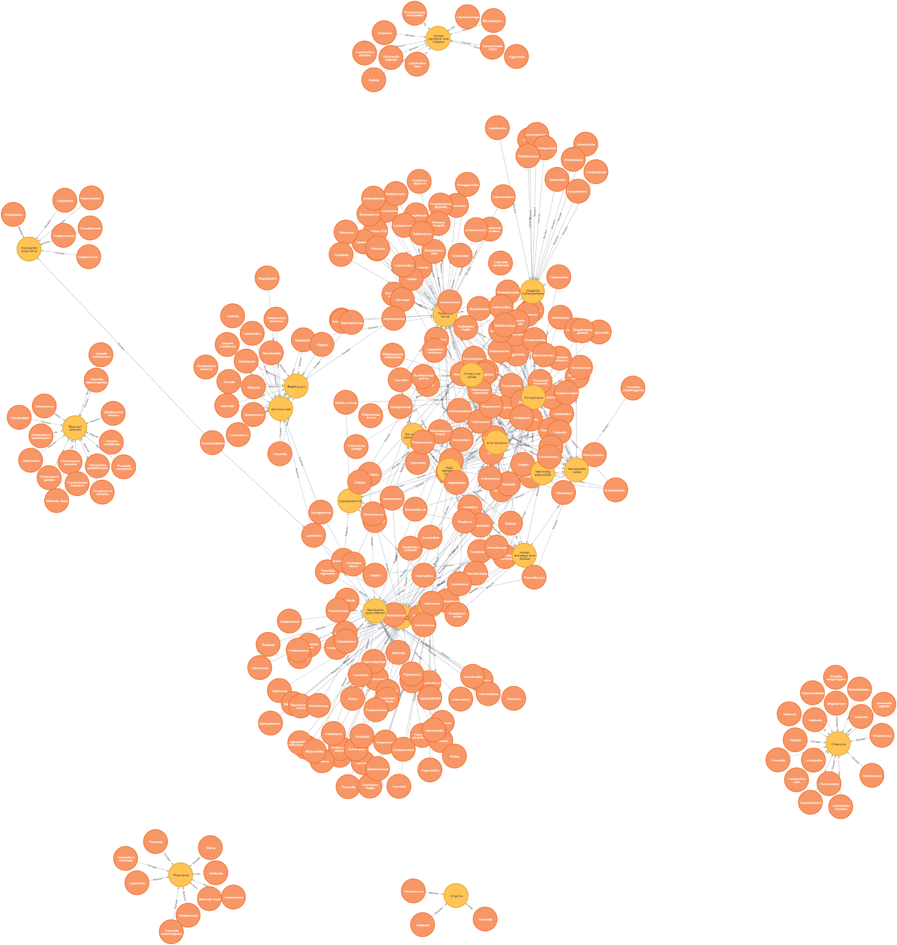

**Which bacteria are associated with cardiovascular diseases?**

match (o:Organism)-[a:Assoc]->(d:Disease{class:"CARDIOVASCULAR"})

return o, a, d

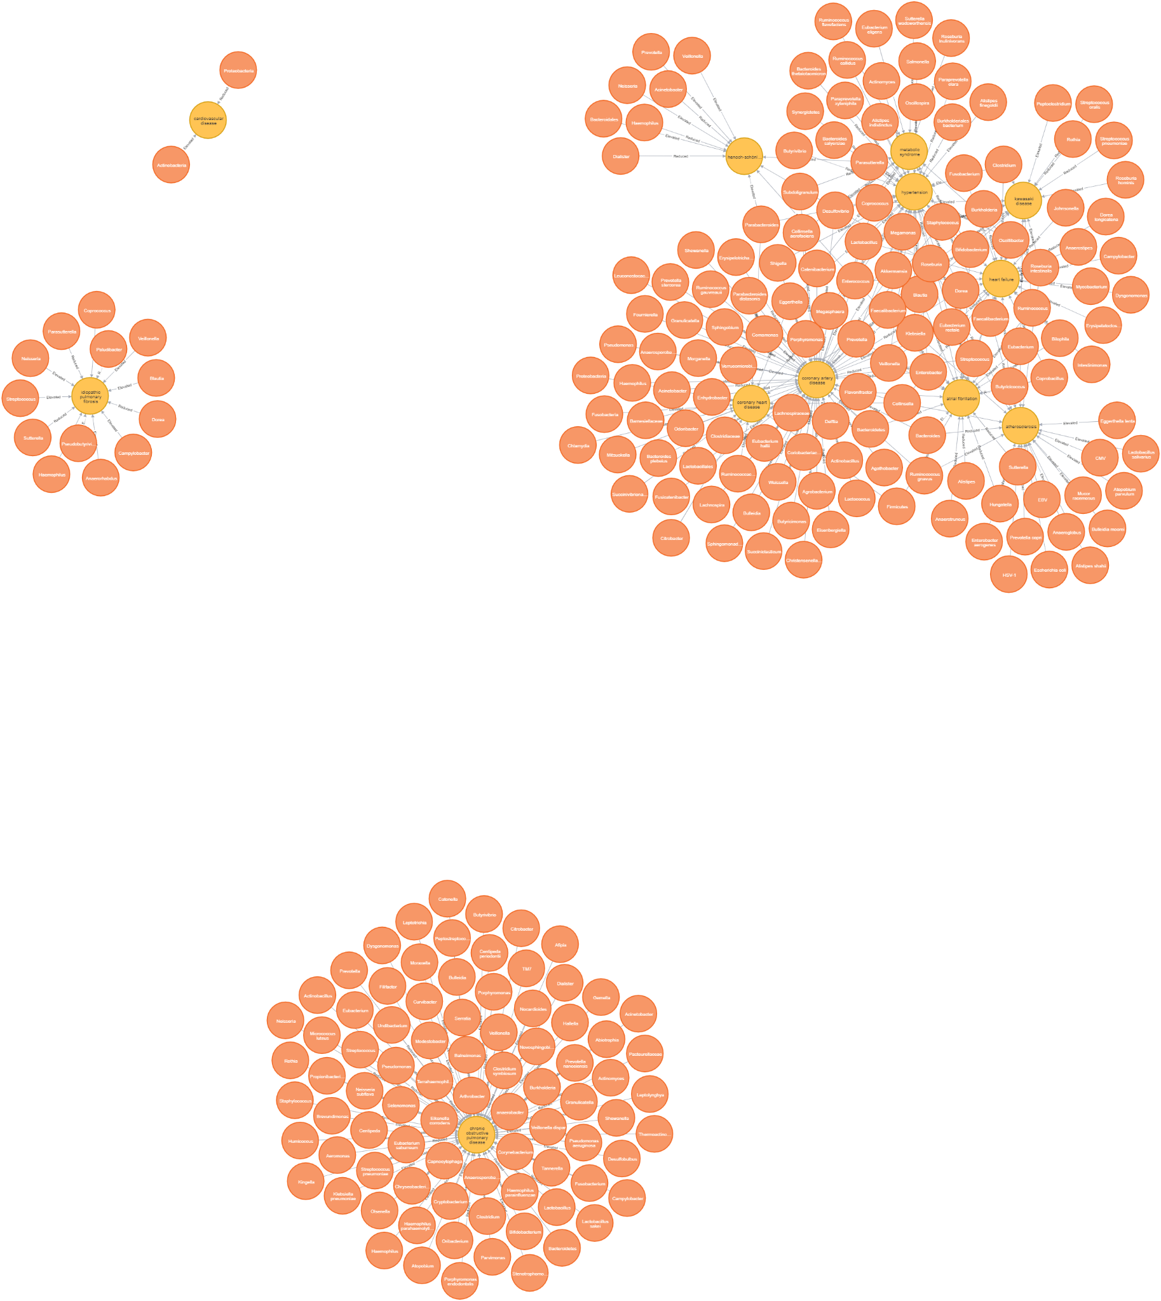

**Common bacteria among cardiovascular diseases?**

match (o:Organism)-[a:Assoc]->(d:Disease{disease:"hypertension"})

match(o)-[a2:Assoc]->(d2:Disease{disease:"atherosclerosis"})

match(o)-[a3:Assoc]->(d3:Disease{disease:"coronary artery disease"})

return o, a, d, d2, a2, d3, a3

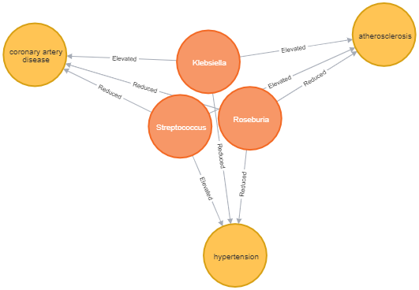

match (o:Organism)-[a:Assoc]->(d:Disease{disease:"hypertension"})

match(o)-[a2:Assoc]->(d2:Disease{disease:"atherosclerosis"})

match(o)-[a3:Assoc]->(d3:Disease{disease:"coronary artery disease"})

match(o)-[a4:Assoc]->(d4:Disease{disease:"heart failure"})

match(o)-[a5:Assoc]->(d5:Disease{disease:"atrial fibrillation"})

return o, a, d, d2, a2, d3, a3, a4, d4, a5, d5

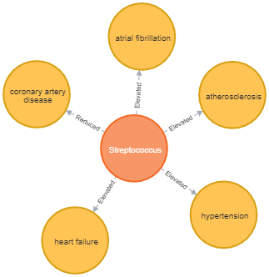

**Which bacteria are most highly linked to mental health disorders?**

match (o:Organism)-[a:Assoc]->(d:Disease)

where d.disease =~ ".*anxiety.*" or d.disease =~".*depressive.*"

or d.disease =~ ".*Bipolar.*"

return o, count(a)

order by count(a) DESC

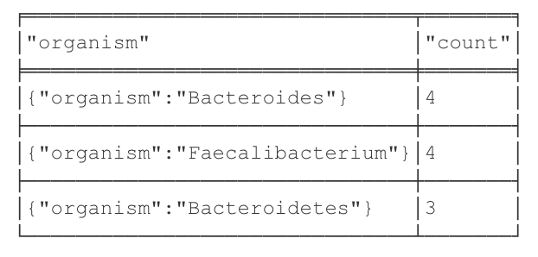

**What diseases are associated with the organisms most highly linked to mental health disorders?**

call {match (o:Organism)-[a:Assoc]->(d:Disease)

where d.disease =~ ".*anxiety.*" or d.disease =~".*depressive.*"

or d.disease =~ ".*Bipolar.*"

with o, count(a) as count

order by count DESC limit 3

return collect(o.organism) as bacteria}

match (o:Organism)-[a:Assoc]->(d:Disease)

where o.organism in bacteria and a.publications > 1

return o,a,d

limit 5

